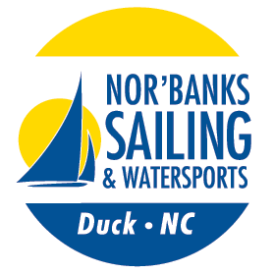
Nor’Banks Sailing
Presents the
2016 Duck Cup

When is it?
Saturday, June 11th & Sunday, June 12th

Who is Welcome?
All Multihulls!!

What is the Course/Adventure?
2 distance races with both races starting and ending at Nor’Banks (competitors are welcome to just enter either day)
The Corp of Engineers have recently installed 5 weather stations in the Currituck Sound which make up a perfect course for the Duck Cup in almost any wind direction. Course for each day will be determined by the weather we have GPS Coordinates for each of the Weather Stations.

How do I win the Coveted Duck Cup?
The Duck Cup will be awarded to the lowest corrected time over the 2-day’s races!
Daily Awards will be given for each race based on corrected time, first across the line and by class (5 boats)
We will run a High Portsmouth and Low Portsmouth, if we get at least 5 High Portsmouth Boats.

What do I do? (Sailing Instructions)
Each day’s race will begin using a Le Mans Style Start at 11am. Starting order will be determined by random drawing on Saturday and on Sunday by your finish on Saturday. Portsmouth Tables will be used for scoring.

Safety?
There is no chase boat or race committee. You will be responsible for your own safety!
We will be monitoring a phone line 252-261-2900 and VHF radio (Channel 7). ,
We suggest bringing a cell phone and/or VHF Handheld.
We will supply charts for everyone, GPS units are permitted and the entire race is in protected waters!

What does it cost?
Entry Fees are $40 for single handed and $50 for double handed
We may do shirts this year! We reserve the right to raise the fees to $50/$60 if we do!!
Extra Shirts and Tickets to the meal on Saturday will be available at the regatta.

What is the Schedule?

Friday
Registration from 12-6

Saturday
Registration from 8-10:00
Skippers Meeting at 10:15
Start at 11am
Cookout, Festivities and 1st Day Awards will be held at Nor’Banks afterwards until?

Sunday
Registration from 8-10:30
Skippers Meeting at 10:30
Start at 11am
Awards to follow Sunday’s racing at Nor’Banks

Please contact Jon Britt at 252-202-6880 or norbanks@gmail.com for more information!

