**NOTICE OF RACE**

**2015 Hobie 33 North American Championships**

**March 26, 2015 – March 29, 2015**

Fort Walton Yacht Club

Fort Walton Beach, Florida

**Brought to you by:**

**BEACH LIQUORS – GULF POOL SERVICES – MAURI PRO SAILING – THE BOAT MARINA**

1. **RULES**
2. The regatta will be governed by the rules as defined in *The Racing Rules of Sailing* (RRS).
3. The Class Rules of the Hobie 33 Class will be in effect with the following adaptations:
4. 9.e Replacement of *wire* with *wire/rope.*
5. 10.b Addition of alternative measurement term *“bearing surface to bearing surface”.*
6. 18.a Deletion of *eight floor boards.*
7. 19. Crew : The minimum crew number shall be five and maximum crew shall be eight. If crew change is required the same number of crew shall be used.
8. **ELIGIBILITY**
9. The Regatta is open to all One Design Hobie 33’s (lift and fixed keel).
10. Eligible boats may enter be completing the entry form and remitting the required fee. Online Entry will be found at : <http://www.nextsailor.com/regatta/2015hobie33>
11. **FEES**

The entry fee is $175.00. Please see online entry site for early registration bonus. Entry deadline is March 20, 2015.

1. **SCHEDULE**

March 26, 2015

4:00pm-6:30pm. Welcome, Check-In, Sail and Pole Measurement, C.R.A.P Party (Crew Recognition and Appreciation Party).

6:30pm-7:00pm. Class Association meeting. One representivitve from each boat please. C.R.A.P Party continues for all others.

March 27, 2015

8:00am-9:30am. Welcome, Check in, Sail and Pole Measurement.

9:45am Skippers Meeting.

11:55am First Warning (multiple races to follow, dockside refreshments provided by Beach Liquors at your slip after racing) Hors d'oeuvres in the Club.

March 28, 2015

8:30am Basic Breakfast for Competitors.

10:55am First Warning (multiple races to follow, dockside refreshments provided by Beach Liquors at your slip after racing).

March 29, 2015

9:00am Club open for Buffet Style Breakfast (pay as you go).

10:55am First Warning. No races shall be started after 2:00pm. Awards Ceremony to Follow ASAP

**5: SAILING INSTRUCTIONS**

The Sailing Instructions will be available Online at http://www.nextsailor.com/regatta/2015hobie33 as of March 15, 2015 as well as at Welcome Table at FWYC March 26 and March 27, 2015.

**6: THE COURSES**

Courses will be available Online at http://www.nextsailor.com/regatta/2015hobie33 as of March 15, 2015 as well as at Welcome Table at FWYC March 26 and March 27, 2015.

**7: SCORING**

1. Unlimited number of races are scheduled.
2. A minimum of two completed races are required to constitute a championship.
3. A boat’s series score will be the total of her race scores. However, a boat’s score shall be the total of her race scores excluding her worst score when five or more races have been completed.

**8: HAUL IN HAUL OUT**

1. Boats shall be afloat by 9:00am and at FWYC by March 27, 2015.
2. Lift Keel Hobie 33’s shall use the ramp at FWYC.
3. Fixed Keel Hobie 33’s shall be launched and retrieved at The Boat Marina free of charge. Please make prior arrangements well ahead of time with Jim Tucker, The Boat Marina: Address: 32 Miracle Strip Parkway Southwest, Fort Walton Beach, FL 32548 850-244-2722.
4. Boats shall not be hauled out during the regatta except with and according to the terms of prior written permission by the Race Committee.
5. Boats will be assigned a wet slip, free of charge, for the duration of the event at FWYC.
6. All Trailer parking shall be at FWYC and free of charge for the duration of the event.
7. A special fee of $10.00 a month dry storage fee has been granted to all Hobie 33’s that wish to leave the boat at FWYC prior to and after the event for travel logistics home and to/from other events.

**9: PRIZES**

1. Prizes shall be awarded to the top five boats in the fleet.
2. The Hobie 33 National Championship Trophy will be awarded to the top finishing boat.
3. A special prize shall be awarded to the Farthest Travelled Boat in the fleet.
4. The Awards Ceremony will take place as soon as possible after the last race of the regatta.

**10: DISCLAMIER OF LIABILITY**

1. It is required that the appropriate amount of insurance be carried by the vessel/vessel owner/vessel representative.
2. Competitors participate in the regatta entirely at their own risk. See RRS Rule 4, Decision to Race. The Fort Walton Yacht Club, Event Organizers, Sponsors, and Event Personnel, will not accept any responsibility for material damage, personal injury, or death sustained in conjunction with the Regatta.
3. Skippers and Crews will be required to sing a Waiver of Liability Form at the Welcome Desk prior to sailing.

**11: ADDITIONAL INFORMATION**

1. FWYC Website: [www.fwyc.org](http://www.fwyc.org)
2. FWYC Office: [office@fwyc.org](mailto:office@fwyc.org) 850-243-7102
3. Fleet Captain John Ferris [fleetcaptain@fwyc.org](mailto:fleetcaptain@fwyc.org) 850-305-9653
4. E.O. Craig & Deborah Wilusz [orlandobass2003@yahoo.com](mailto:orlandobass2003@yahoo.com) 850-543-5666
5. Next Sailor Event Site <http://www.nextsailor.com/regatta/2015hobie33>
6. Facebook Site <https://www.facebook.com/Hobie33NAC2015>

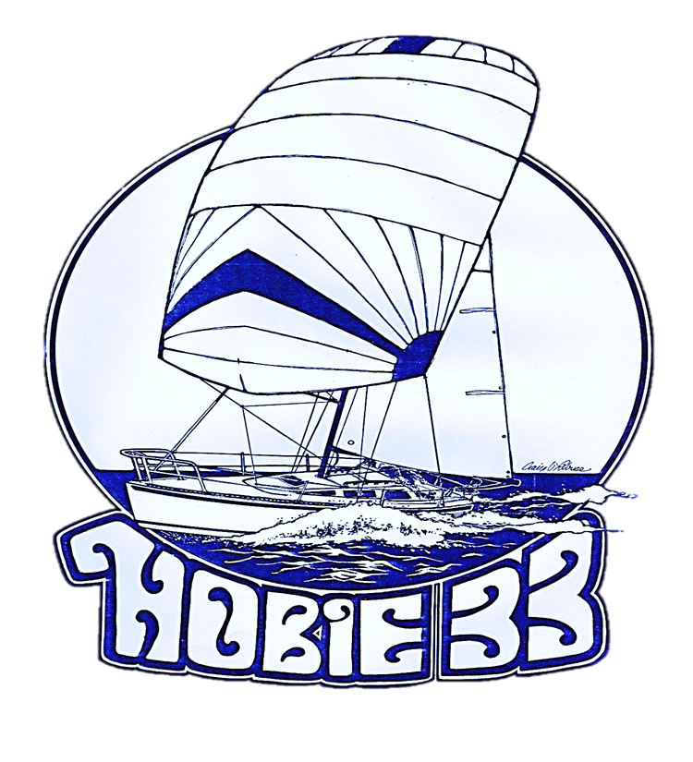

2015 NORTH AMERICAN CHAMPIONSHIPS

Fort Walton Yacht Club , Florida

March 26-29, 2015