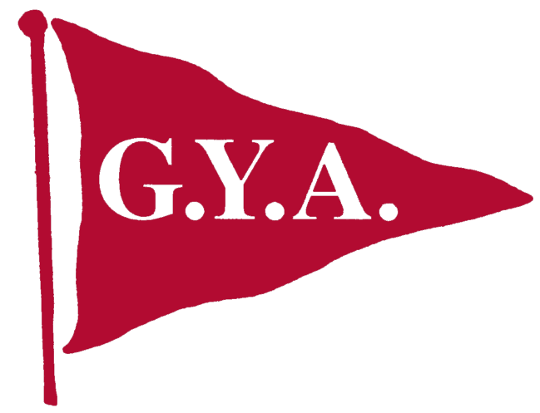
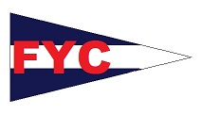
Notice of Race
GYA Opening Regatta 2016
May 20, 21, &22
Fairhope Yacht Club
101 Volanta Avenue, Fairhope AL 36532.

Rules
All races will be governed by the 2013-2016 Racing Rules of Sailing, the current prescriptions of U.S. Sailing, One Design Class rules when not in conflict with the forgoing, and FYC Sailing Instructions. Registration:
Registration available online at http://www.nextsailor.com/regatta/59 and will be held Friday evening and Saturday morning at the FYC clubhouse, as outlined below. If you are planning to bring a powerboat to spectate and would consider being a safty boat please email me at fitz1350@bellsouth.net and let me know which course you plan on being on.
Classes
Capdevielle, Master (Flying Scot), Viper, VX One, R19, Laser, Laser Radial, Sunfish, Opti, 420.

Schedule of Events
Friday

Saturday
0930-1045 Registration for Capdevielle, Master, One Design & Juniors, continental breakfast
0900 GYA Board of Directors meeting
1100 Capdevielle, Masters, One Design & Youth Skippers meeting
1200 Flag Ceremony
1255 Capdevielle, Masters, One Design & Youth Warning Signals (Races conducted back to back)
1730- 2000 Commodore's Reception
Sunday
1025 All Capdevielle, Masters, One Design & Youth Classes – Warning Signal – races conducted back to back. Trophy Presentations as soon as practical following the last race of the day.

Food & Entertainment
Friday 1730 Bar open and full menu is available
Sat. & Sun. 0830 -1000 Continental Breakfast will be provided:
1030 - 2100 Regular restaurant hours
Saturday 1030 -1230 Burgers and Hot Dogs available under the club, $5
1600 -1900 The Boat Barn, food options, $10 and under, and music by Ground Level Fault.
1730- 2000 Commodore's Reception
Sunday 1330 -1530 Sunday a Po-boy buffet available for $10

Note: Bag lunches are available on Saturday . Please order at the club one day early (251) 928-8888.

Sailing Instructions
The Sailing instructions will be available at registration.

Racing Area
The racing area will be Mobile Bay.

Entry Fees
Youth Classes ----------$30 ($25 USSA Member) – Opti, 420, Laser Radial, Laser, Sunfish
One Design ----------$40 ($35 USSA Member) – Masters, Viper and VX One, R19
Capdevielle/ Club Viper ----------No Entry Fee
Immediate Family Discount, $10 off for each additional boat.

Scoring
Scoring will be in accordance with RRS Appendix A except that the number of races completed to allow one (1) throw-out is six (6). (This Changes RRS A2). Ties will be resolved in accordance with RRS Appendix A. Multiple races will be attempted, however, one race completed shall constitute a series.

Lodging
Local Accommodations are (251) Key West Inn @990-7373, Marriot Grand Hotel @ 928-9201, Holiday Inn Express @ 928-9191. Other Hotels are available within the Daphne/Fairhope area.

Regatta Contacts:
Vice-Commodore Randy Fitz-Wainwright (251) 377-8419 or e-mail fitz1350@bellsouth.net , Pat Colvin, FYC Office Manager 251-928-3276 office@fairhopeyachtclub.com

