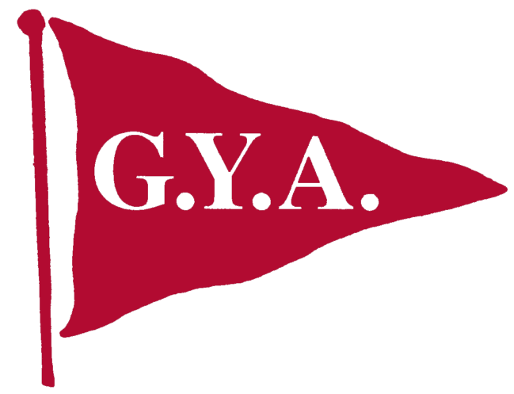
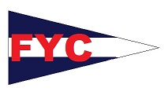
Notice of Race
Wadewitz Regatta 2015
September 25, 26, &27
Fairhope Yacht Club
101 Volanta Avenue, Fairhope AL 36532.

Rules
All races will be governed by the 2013-2016 Racing Rules of Sailing, the current prescriptions of U.S. Sailing, One Design Class rules when not in conflict with the forgoing, and FYC Sailing Instructions.

Registration:
Registration available online at nextsailor.com and will be held Friday evening and Saturday morning at the FYC clubhouse, as outlined below. If you are planning to bring a powerboat to spectate and would consider being a safty boat please go to the sign up genius link at fairhopeyachtclub.com and let us know which course you plan on being on.

Classes
Capdevielle, PHRF & Portsmouth, Viper, VX One, U20, Finn, Fish, R19, Laser, Laser Radial, Sunfish, Opti, 420.

Schedule of Events
Friday
1730 -1900 Registration for PHRF, Portsmouth
1930 Above Registered Boats Skippers Meeting
Saturday
0930-1045 Registration for One Design & Juniors, continental breakfast
1055 PHRF, Portsmouth Warning Signal
1100 One Design & Youth Skippers meeting
1225 One Design & Youth Warning Signals (Races conducted back to back)

Sunday
1025 All Classes – Warning Signal – races conducted back to back
Trophy Presentations as soon as practical following the last race of the day.

Food & Entertainment
Friday 1730 Bar open and full menu is available
Sat. & Sun. 0830 -1000 Continental Breakfast will be provided:
1030 - 2100 Regular restaurant hours
Saturday 1030 -1230 Burgers and Hot Dogs available under the club, $5
1600 -1830 Under the Club House food, options $10 and under, and music by Ground Level Fall.
Sunday 1330 -1530 Sunday a Po-boy buffet available for $10

Note: Bag lunches are available on Saturday . Please order at the club one day early (251) 928-8888.

Sailing Instructions
The Sailing instructions will be available at registration.

Racing Area
The racing area will be Mobile Bay.

Entry Fees
Youth Classes ----------$30 ($25 USSA Member) – Opti, 420, Laser Radial
One Design ----------$40 ($35 USSA Member) – Viper, VX One, U20, Finn, Fish, R19, Laser, Sunfish
PHRF/Portsmouth ---------$40 ($35 USSA Member)
Capdevielle ----------No Entry Fee
Immediate Family Discount, $10 off for each additional boat.

Scoring
Scoring will be in accordance with RRS Appendix A except that the number of races completed to allow one (1) throw-out is six (6). (This Changes RRS A2). Ties will be resolved in accordance with RRS Appendix A. Multiple races will be attempted, however, one race completed shall constitute a series.

Lodging
Local Accommodations are (251) Key West Inn @990-7373, Marriot Grand Hotel @ 928-9201, Holiday Inn Express @ 928-9191. Other Hotels are available within the Daphne/Fairhope area.

Regatta Contacts:
Rear Commodore Randy Fitz-Wainwright or e-mail fitz1350@bellsouth.net , Pat Colvin, FYC Office Manager 251-928-3276 office@fairhopeyachtclub.com

